Devin Fromond
Lab Report
ECE 2031 L04
22 October 2025

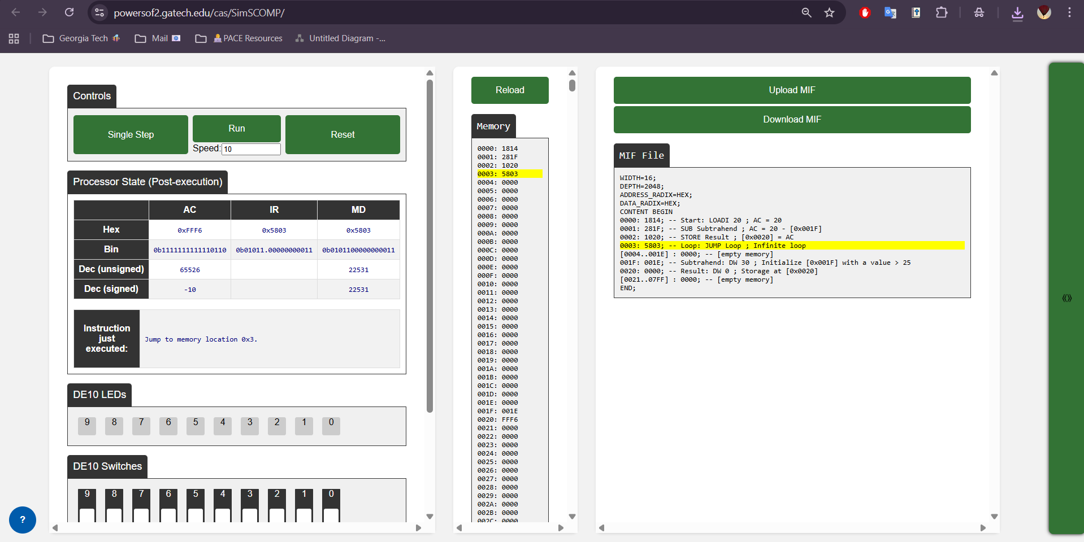Figure 1. SCOMP processor simulator showing the custom assembly program assembled and executing within the infinite loop, confirming correct operation of the LOADI, SUB, and STORE instructions.

; SimpleSubAndStore.asm (ASM)
; Load 20, sub contents of 0x1F, store to 0x20, loop forever
; Devin Fromond
; ECE2031 L4
; 10/18/2025

ORG 0
Start: LOADI 20 ; AC = 20
SUB Subtrahend ; AC = 20 - [0x001F]
STORE Result ; [0x0020] = AC

Loop: JUMP Loop ; Infinite loop

ORG &H001F
Subtrahend: DW 30 ; init [0x001F] with a value > 25

ORG &H0020
Result: DW 0 ; Storage at [0x0020]
Figure 2. ASM code used to demonstrate functionality of load, subtract, and store operations.

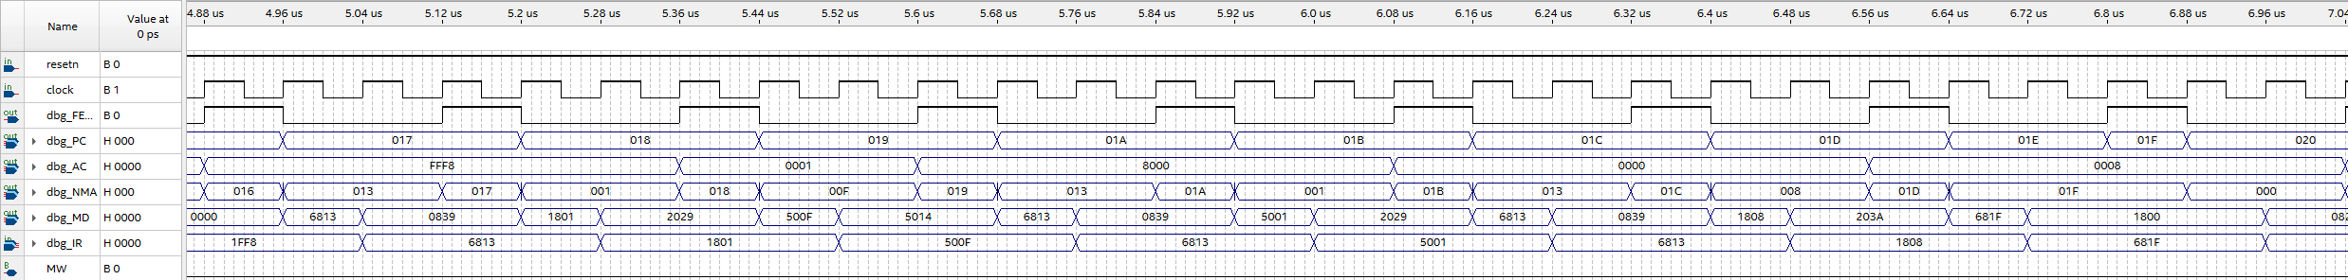
Figure 3. Waveform simulation demonstrating working JPOS (Jump POSitive) and JNZ (Jump Not Zero) functionality (best observed on the dbg_AC line) for the corresponding VDHL file as in Appendix A.
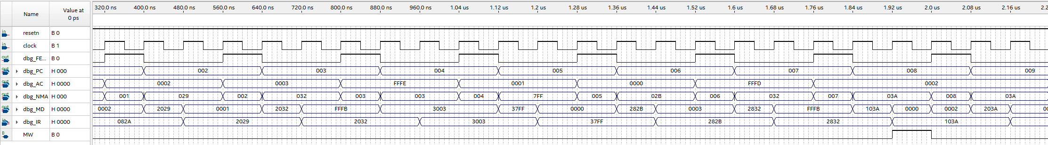
Figure 4. Waveform simulation demonstrating working SUB (SUBtract) functionality (best observed on the dbg_AC) for the corresponding VDVL file as in Appendix A.

APPENDIX A
VDHL FILE CONTAINING ADDED JPOS/JNZ/SUB OPCODES AND FUNCTIONALITY

-- SCOMP.vdh
-- Basic Opcode defs and jpos/jnz/sub functionality
-- Devin Fromond
-- ECE 2031 L04
-- 10/18/2025

-- SCOMP, the Simple Computer.
-- A 16-bit computer designed to be easy to design and modify.
-- Updated 2025

library altera_mf;
library lpm;
library ieee;

use altera_mf.altera_mf_components.all;
use lpm.lpm_components.all;
use ieee.std_logic_1164.all;
use ieee.std_logic_unsigned.all;
use ieee.std_logic_arith.all;

entity SCOMP is
port(
clock : in std_logic;
resetn : in std_logic;
IO_READ : out std_logic;
IO_WRITE : out std_logic;
IO_ADDR : out std_logic_vector(10 downto 0);
IO_DATA : inout std_logic_vector(15 downto 0);
dbg_FETCH : out std_logic;
dbg_AC : out std_logic_vector(15 downto 0);
dbg_PC : out std_logic_vector(10 downto 0);
dbg_NMA : out std_logic_vector(10 downto 0);
dbg_MD : out std_logic_vector(15 downto 0);
dbg_IR : out std_logic_vector(15 downto 0)
);
end SCOMP;

architecture a of SCOMP is
type state_type is (
init, fetch, decode,
ex_nop, ex_load, ex_store, ex_store2,
ex_loadi, ex_add, ex_sub, ex_jpos, ex_jnz, ex_addi,
ex_and, ex_or, ex_xor, ex_shift,
ex_jump, ex_jneg, ex_jzero,
ex_return, ex_call,
ex_in, ex_in2, ex_out, ex_out2
);

-- custom type for the call stack
constant STACK_SIZE : integer := 10;
type stack_type is array (0 to STACK_SIZE)
of std_logic_vector(10 downto 0);

-- internal signals
signal state : state_type;
signal AC : std_logic_vector(15 downto 0);
signal AC_shifted : std_logic_vector(15 downto 0);
signal PC_stack : stack_type;
signal IR : std_logic_vector(15 downto 0);
signal mem_data : std_logic_vector(15 downto 0);
signal PC : std_logic_vector(10 downto 0);
signal next_mem_addr : std_logic_vector(10 downto 0);
signal operand : std_logic_vector(10 downto 0);
signal MW : std_logic;
signal io_drive_en : std_logic;

begin
-- use altsyncram for unified program and data memory
altsyncram_component : altsyncram
GENERIC MAP (
numwords_a => 2048,
widthad_a => 11,
width_a => 16,
init_file => "SimpleDemo.mif",
clock_enable_output_a => "BYPASS",
lpm_hint => "ENABLE_RUNTIME_MOD=NO",
intended_device_family => "CYCLONE V",
clock_enable_input_a => "BYPASS",
lpm_type => "altsyncram",
operation_mode => "SINGLE_PORT",
power_up_uninitialized => "FALSE",
read_during_write_mode_port_a=>"NEW_DATA_NO_NBE_READ",
outdata_reg_a => "UNREGISTERED",
outdata_aclr_a => "NONE",
width_byteena_a => 1
)
PORT MAP (
wren_a => MW,
clock0 => clock,
address_a => next_mem_addr,
data_a => AC,
q_a => mem_data
);

-- use Intel IP to shift AC for shift instruction
shifter: lpm_clshift
generic map (
lpm_width => 16,
lpm_widthdist => 4,
lpm_shifttype => "arithmetic"
)
port map (
data => AC,
distance => IR(3 downto 0),
direction => IR(4),
result => AC_shifted
);

-- Memory address comes from PC during fetch
with state select next_mem_addr <=
PC when fetch,
operand when others;

-- This makes the operand available immediately after fetch
with state select operand <=
mem_data(10 downto 0) when decode,
IR(10 downto 0) when others;

-- use lpm tri-state driver to drive i/o bus
io_bus: lpm_bustri
generic map (
lpm_width => 16
)
port map (
data => AC,
enabledt => io_drive_en,
tridata => IO_DATA
);

-- IR has the IO address during INs and OUTs
IO_ADDR <= IR(10 downto 0);

process (clock, resetn)
begin
if (resetn = '0') then -- Active-low reset
state <= init;
elsif (rising_edge(clock)) then
case state is
when init =>
MW <= '0'; -- clear mem w flag
PC <= "00000000000"; -- reset PC
AC <= x"0000"; -- clear AC
io_drive_en <= '0'; -- don't drive IO
state <= fetch; -- start cycles

when fetch =>
io_drive_en <= '0'; -- stop driving IO
PC <= PC + 1; -- increment PC
state <= decode;

when decode =>
IR <= mem_data; -- latch inst
case mem_data(15 downto 11) is
when "00000" => -- nop
state <= ex_nop;
when "00001" => -- load
state <= ex_load;
when "00010" => -- store
MW <= '1'; -- mem wr
state <= ex_store;
when "00011" => -- loadi
state <= ex_loadi;
when "00100" => -- add
state <= ex_add;
when "00101" => -- sub
state <= ex_sub;
when "00110" => -- addi
state <= ex_addi;
when "00111" => -- and
state <= ex_and;
when "01000" => -- or
state <= ex_or;
when "01001" => -- xor
state <= ex_xor;
when "01010" => -- shift
state <= ex_shift;
when "01011" => -- jump
state <= ex_jump;
when "01100" => -- jneg
state <= ex_jneg;
when "01101" => -- jpos
state <= ex_jpos;
when "01110" => -- jzero
state <= ex_jzero;
when "01111" => -- jnz
state <= ex_jnz;
when "10000" => -- call
state <= ex_call;
when "10001" => -- return
state <= ex_return;
when "10010" => -- in
state <= ex_in;
when "10011" => -- out
state <= ex_out;
io_drive_en <= '1';
when others =>
state <= ex_nop;
end case;

when ex_nop =>
state <= fetch;
when ex_load =>
AC <= mem_data; -- latch data
state <= fetch;

when ex_store =>
MW <= '0'; -- drop MW to end write
state <= fetch;

when ex_loadi => -- sign-extend
AC <= (IR(10) & IR(10) & IR(10) &
IR(10) & IR(10) & IR(10 downto 0));
state <= fetch;

when ex_add =>
AC <= AC + mem_data; -- addition
state <= fetch;

when ex_addi =>
-- sign extension
AC <= AC + (IR(10) & IR(10) &IR(10 &
IR(10) & IR(10) & IR(10 downto 0));
state <= fetch;

when ex_jump =>
PC <= operand -- overwrite PC
state <= fetch;

when ex_jneg =>
if (AC(15) = '1') then
PC <= operand;
end if;
state <= fetch;

when ex_jzero =>
if (AC = x"0000") then
PC <= operand;
end if;
state <= fetch;

when ex_and =>
AC <= AC and mem_data; -- AND
state <= fetch;

when ex_or =>
AC <= AC or mem_data;
state <= fetch;

when ex_xor =>
AC <= AC xor mem_data;
state <= fetch;

when ex_shift =>
AC <= AC_shifted;
state <= fetch;

when ex_call =>
for i in 0 to STACK_SIZE-1 loop
PC_stack(i + 1) <= PC_stack(i);
end loop;
PC_stack(0) <= PC;
PC <= operand;
state <= fetch;

when ex_return =>
for i in 0 to STACK_SIZE-1 loop
PC_stack(i) <= PC_stack(i + 1);
end loop;
PC <= PC_stack(0);
state <= fetch;

when ex_in =>
IO_READ <= '1'
state <= ex_in2;

when ex_in2 =>
IO_READ <= '0';
AC <= IO_DATA;
state <= fetch;

when ex_out =>
IO_WRITE <= '1';
state <= ex_out2;

when ex_out2 =>
IO_WRITE <= '0';
state <= fetch;
-- SUB: AC <= AC - MEM(Address)

when ex_sub =>
AC <= AC - mem_data;
state <= fetch;

-- JPOS: If AC > 0 , jump.
when ex_jpos =>
if (AC(15)='0' and AC/= x"0000") then
PC <= operand;
end if;
state <= fetch;

-- JNZ: If AC /= 0, jump.
when ex_jnz =>
if (AC /= x"0000") then
PC <= operand;
end if;
state <= fetch;

when others =>
state <= init;

end case;
end if;
end process;

-- Additional outputs to aid simulation
dbg_FETCH <= '1' when state = fetch else '0';
dbg_PC <= PC;
dbg_AC <= AC;
dbg_IR <= IR;
dbg_NMA <= next_mem_addr;
dbg_MD <= mem_data;

end a;

APPENDIX B
ASM FILE FOR AN SCOMP BYTE-DIFFERENCE PROGRAM

; ByteDiff.asm
; Compute |high_byte(Value) - low_byte(Value)| and st in Result
; Devin Fromond
; ECE 2031 L04
; 10/18/2025
ORG 0
Start:
; --- Grab HIGH BYTE into High
LOAD Value ; AC = 0xHHLL
AND HiMask ; AC = 0xHH00
SHIFT -8 ; arithmetic >>8 may sign-extend...
AND LowMask ; AC = 0x00HH
STORE High

; --- Grab LOW BYTE into Low
LOAD Value ; AC = 0xHHLL
AND LowMask ; AC = 0x00LL
STORE Low

; --- Compute (High - Low)
LOAD High ; AC = High
SUB Low ; AC = High - Low
JNEG MakePos ; if negative, negate it
STORE Result ; already positive
JUMP Finish

MakePos:
STORE Diff ; Diff = (High - Low) < 0
LOADI 0
SUB Diff ; AC = -Diff = |High - Low|
STORE Result

Finish:
JUMP Finish ; Infinite loop

Value: DW &H89F1 ; Start with 0x89F1 (expected 104)
; Test Case: HF000 (expected 240)
; Test Case: HFFFF (expected 0)
; Test Case: H1248 (expected 54)
Result: DW 0
High: DW 0
Low: DW 0
Diff: DW 0

LowMask: DW &H00FF
HiMask: DW &HFF0

